

DEPARTMENT OF ARTIFICIAL INTELLIGENCE AND DATA SCIENCE

LAB MANUAL
III YEAR / VI SEMESTER
2025-2026

IT4658- DEEP LEARNING LAB

Name : Ms. R. ABIRAMI /Ms.S.B.PRIYA
Designation : Assistant Professor
Department : Artificial Intelligence and Data Science

Ex No:1 Implementing a Perceptron Algorithm for Binary Classification
Date:
Aim: To Implement a Perceptron Algorithm for Binary Classification
Algorithm:
- Initialize weights to zeros and bias to zero.
- Convert all target labels to -1 or 1.
- For a fixed number of iterations, repeat the training loop.
- For each training example, compute the linear output using dot product of input and weights plus bias.
- Apply the sign function to get the predicted class label.
- Compare predicted label with actual label.
- If prediction is incorrect, update weights by adding learning_rate × label × input.
- Also update bias by adding learning_rate × label.
- Repeat for all training samples and iterations.
- For prediction, use the trained weights and bias with the sign of the linear output.

Program:
import numpy as np
class Perceptron:
def __init__(self, learning_rate=0.01, n_iter=1000):
self.learning_rate = learning_rate
self.n_iter = n_iter
self.weights = None
self.bias = None
def fit(self, X, y):
"""
Fit the model to the data.
X: ndarray, shape (n_samples, n_features) - Input features.
y: ndarray, shape (n_samples,) - Target labels (-1 or 1).
"""
n_samples, n_features = X.shape
self.weights = np.zeros(n_features)
self.bias = 0
# Ensure y is either -1 or 1
y = np.where(y <= 0, -1, 1)
for _ in range(self.n_iter):
for idx, x_i in enumerate(X):
linear_output = np.dot(x_i, self.weights) + self.bias
y_predicted = np.sign(linear_output)
# Update weights and bias if there is a misclassification
if y_predicted != y[idx]:
self.weights += self.learning_rate * y[idx] * x_i
self.bias += self.learning_rate * y[idx]
def predict(self, X):
"""
Predict labels for given input data.
X: ndarray, shape (n_samples, n_features) - Input features.
Returns: ndarray, shape (n_samples,) - Predicted labels (-1 or 1).
"""
linear_output = np.dot(X, self.weights) + self.bias
return np.sign(linear_output)
# Example usage:
if __name__ == "__main__":
# Example dataset
X = np.array([
[1, 2],
[2, 3],
[3, 4],
[1, 0],
[0, 1],
[3, 1]
])
y = np.array([1, 1, 1, -1, -1, -1]) # Binary labels
# Create and train the perceptron
perceptron = Perceptron(learning_rate=0.1, n_iter=10)
perceptron.fit(X, y)
# Predict new data points
predictions = perceptron.predict(X)
print("Predicted labels:", predictions)
print("Actual labels: ", y)
OUTPUT:
Predicted labels: [ 1. 1. 1. -1. -1. -1.]
Actual labels: [ 1 1 1 -1 -1 -1]

Result:
Thus the Implementation of a Perceptron Algorithm for Binary Classification is executed successfully

EX NO:2 Implementing a Feed-Forward Neural Network for Regression
Aim:

To Implement a Feed-Forward Neural Network for Regression

Algorithm:
- Initialize weights and biases for input-hidden and hidden-output layers.
- Normalize the input and output data.
- For each epoch, repeat steps 4–8.
- Compute hidden layer input: X • weights_input_hidden + bias_hidden.
- Apply sigmoid activation to hidden input.
- Compute output layer input: hidden_output • weights_hidden_output + bias_output.
- Calculate error: y - predicted_output.
- Perform backpropagation to update weights and biases.
- Optionally, compute and display loss every 100 epochs.
- After training, use the model to predict output using the forward pass.

Program
import numpy as np
class FeedForwardNN:
def __init__(self, n_input, n_hidden, n_output, learning_rate=0.01):
self.learning_rate = learning_rate
# Initialize weights and biases
self.weights_input_hidden = np.random.randn(n_input, n_hidden) * 0.1
self.bias_hidden = np.zeros(n_hidden)
self.weights_hidden_output = np.random.randn(n_hidden, n_output) * 0.1
self.bias_output = np.zeros(n_output)
def sigmoid(self, x):
"""Sigmoid activation function."""
return 1 / (1 + np.exp(-x))
def sigmoid_derivative(self, x):
"""Derivative of the sigmoid function."""
return x * (1 - x)
def forward(self, X):
"""Forward pass."""
self.hidden_input = np.dot(X, self.weights_input_hidden) + self.bias_hidden
self.hidden_output = self.sigmoid(self.hidden_input)
self.final_input = np.dot(self.hidden_output, self.weights_hidden_output) + self.bias_output
self.final_output = self.final_input # Linear activation for regression
return self.final_output
def backward(self, X, y, output):
"""Backward pass."""
# Calculate errors
error = y - output
output_gradient = -2 * error
# Backpropagation
hidden_error = np.dot(output_gradient, self.weights_hidden_output.T)
hidden_gradient = hidden_error * self.sigmoid_derivative(self.hidden_output)
# Update weights and biases
self.weights_hidden_output -= self.learning_rate * np.dot(self.hidden_output.T, output_gradient)
self.bias_output -= self.learning_rate * np.sum(output_gradient, axis=0)
self.weights_input_hidden -= self.learning_rate * np.dot(X.T, hidden_gradient)
self.bias_hidden -= self.learning_rate * np.sum(hidden_gradient, axis=0)
def fit(self, X, y, epochs):
"""Train the neural network."""
for epoch in range(epochs):
output = self.forward(X)
self.backward(X, y, output)
if epoch % 100 == 0:
loss = np.mean((y - output) ** 2)
print(f"Epoch {epoch}, Loss: {loss}")
def predict(self, X):
"""Make predictions."""
return self.forward(X)
# Example usage
if __name__ == "__main__":
# Example dataset
X = np.array([[0], [1], [2], [3], [4]], dtype=float)
y = np.array([[0], [2], [4], [6], [8]], dtype=float) # Linear relationship: y = 2x
# Scale data
X /= np.max(X)
y /= np.max(y)
# Create and train the model
nn = FeedForwardNN(n_input=1, n_hidden=10, n_output=1, learning_rate=0.1)
nn.fit(X, y, epochs=1000)
# Test predictions
predictions = nn.predict(X)
print("Predictions:", predictions)
print("Actual values:", y)
OUTPUT:
Epoch 0, Loss: 0.423209316523922
Epoch 100, Loss: 0.012751554694317487
Epoch 200, Loss: 0.004091264310811452
Epoch 300, Loss: 0.003407964147190816
Epoch 400, Loss: 0.003261432113502563
Epoch 500, Loss: 0.0031387241587497255
Epoch 600, Loss: 0.0030218435029647278
Epoch 700, Loss: 0.002910123186987161
Epoch 800, Loss: 0.0028033722960642423
Epoch 900, Loss: 0.0027014068416472323
Predictions: [[-0.04943591]
[ 0.29121125]
[ 0.55959607]
[ 0.76843809]
[ 0.92938637]]
Actual values: [[0. ]
[0.25]
[0.5 ]
[0.75]
[1. ]]

Result:
Thus the Implementing a Feed-Forward Neural Network for Regression is executed successfully.

Ex: No: 3 Implementing a Deep-Feed- Forward Neural Network for Image Classification
Date:

AIM: To Implement a Deep-Feed- Forward Neural Network for Image Classification

ALGORITHM:
- Import required libraries (TensorFlow, Keras, NumPy, scikit-learn, Matplotlib).
- Load the MNIST dataset and split it into training and test sets.
- Display the shape of the datasets and visualize the first 10 images with labels.
- Reshape images to 784-dimensional vectors and normalize pixel values by dividing by 255.
- Create a Sequential model with an input layer of 784 neurons.
- Add three hidden layers with 128, 64, and 32 neurons using ReLU activation.
- Add an output layer with 10 neurons using softmax activation.
- Compile the model using the Adam optimizer and Sparse Categorical Crossentropy loss.
- Train the model for 5 epochs with a batch size of 10 and a 20% validation split.
- Evaluate performance using predictions and display classification reports.

Program:
#load required packages import tensorflow as tf
from tensorflow import keras
from keras.models import Sequential from keras import Input
from keras.layers import Dense import pandas as pd
import numpy as np import sklearn
from sklearn.metrics import classification_report import matplotlib
import matplotlib.pyplot as plt
# Load digits data
(X_train, y_train), (X_test, y_test) = keras.datasets.mnist.load_data()
# Print shapes
print("Shape of X_train: ", X_train.shape) print("Shape of y_train: ", y_train.shape) print("Shape of X_test: ", X_test.shape) print("Shape of y_test: ", y_test.shape)
# Display images of the first 10 digits in the training set and their true lables fig, axs = plt.subplots(2, 5, sharey=False, tight_layout=True, figsize=(12,6), facecolor='white')
n=0
for i in range(0,2):
for j in range(0,5): axs[i,j].matshow(X_train[n]) axs[i,j].set(title=y_train[n]) n=n+1
plt.show()
# Reshape and normalize (divide by 255) input data
X_train = X_train.reshape(60000, 784).astype("float32") / 255 X_test = X_test.reshape(10000, 784).astype("float32") / 255
# Print shapes
print("New shape of X_train: ", X_train.shape) print("New shape of X_test: ", X_test.shape)
#Design the Deep FF Neural Network architecture model = Sequential(name="DFF-Model") # Model
model.add(Input(shape=(784,), name='Input-Layer')) # Input Layer - need to specify the shape of inputs
model.add(Dense(128, activation='relu', name='Hidden-Layer-1', kernel_initializer='HeNormal'))
model.add(Dense(64, activation='relu', name='Hidden-Layer-2', kernel_initializer='HeNormal'))
model.add(Dense(32, activation='relu', name='Hidden-Layer-3', kernel_initializer='HeNormal'))
model.add(Dense(10, activation='softmax', name='Output-Layer'))
#Compile keras model
model.compile(optimizer='adam', loss='SparseCategoricalCrossentropy', metrics=['Accuracy'], loss_weights=None, weighted_metrics=None, run_eagerly=None, steps_per_execution=None)
#Fit keras model on the dataset
model.fit(X_train, y_train, batch_size=10, epochs=5, verbose='auto', callbacks=None, validation_split=0.2, shuffle=True, class_weight=None, sample_weight=None, initial_epoch=0, # Integer, default=0, Epoch at which to start training (useful for resuming a previous training run).
steps_per_epoch=None, validation_steps=None, validation_batch_size=None, validation_freq=5, max_queue_size=10, workers=1, use_multiprocessing=False,)
# apply the trained model to make predictions # Predict class labels on training data
pred_labels_tr = np.array(tf.math.argmax(model.predict(X_train),axis=1)) # Predict class labels on a test data
pred_labels_te = np.array(tf.math.argmax(model.predict(X_test),axis=1))
#Model Performance Summary print("")
print(' Model Summary ') model.summary()
print("")
# Printing the parameters:Deep Feed Forward Neural Network contains more than 100K
#print(' Weights and Biases ') #for layer in model_d1.layers:
#print("Layer: ", layer.name) # print layer name
#print(" --Kernels (Weights): ", layer.get_weights()[0]) # kernels (weights) #print(" --Biases: ", layer.get_weights()[1]) # biases
print("")
print('---------- Evaluation on Training Data ')
print(classification_report(y_train, pred_labels_tr)) print("")
print('---------- Evaluation on Test Data ')
print(classification_report(y_test, pred_labels_te)) print("")

OUTPUT:
Epoch 1/5
4800/4800 [==============================] - 10s 2ms/step - loss: 0.2923 - accuracy: 0.9158 - val_loss: 0.1690 - val_accuracy: 0.9517
...
Epoch 5/5
4800/4800 [==============================] - 10s 2ms/step - loss: 0.0617 - accuracy: 0.9817 - val_loss: 0.1148 - val_accuracy: 0.9672

Result:
Thus the implementation of a Deep-Feed- Forward Neural Network for Image Classification is executed successfully
Ex: No: 4 Implementing Regularization Techniques Deep Learning
Date:

AIM: To implement regularization techniques in a deep learning model to prevent overfitting and improve generalization.

ALGORITHM:
- Import required libraries (TensorFlow, Keras, NumPy).
- Load and preprocess the dataset (reshape and normalize).
- Define a Sequential model with an input layer.
- Add hidden layers with L2 regularization using kernel_regularizer.
- Apply Dropout layers to randomly drop neurons during training.
- Use Batch Normalization to stabilize learning.
- Add an output layer with softmax activation.
- Compile the model using the Adam optimizer and Sparse Categorical Crossentropy loss.
- Train the model with appropriate batch size and epochs.
- Evaluate model performance and compare results with and without regularization.

Program:
import numpy as np
import matplotlib.pyplot as plt
import tensorflow as tf
from tensorflow import keras
from tensorflow.keras import layers, regularizers
import torch
import torch.nn as nn
import torch.optim as optim
from torch.utils.data import DataLoader, TensorDataset
# Load MNIST dataset
(X_train, y_train), (X_test, y_test) = keras.datasets.mnist.load_data()
# Normalize the data
X_train, X_test = X_train / 255.0, X_test / 255.0
# Flatten the images
X_train = X_train.reshape(-1, 28*28)
X_test = X_test.reshape(-1, 28*28)
# Convert labels to categorical (one-hot encoding)
y_train = keras.utils.to_categorical(y_train, 10)
y_test = keras.utils.to_categorical(y_test, 10)
model = keras.Sequential([
layers.Dense(512, activation='relu', kernel_regularizer=regularizers.l2(0.01)), # L2 Regularization
layers.Dropout(0.5), # Dropout Regularization
layers.BatchNormalization(), # Batch Normalization
layers.Dense(256, activation='relu', kernel_regularizer=regularizers.l1(0.01)), # L1 Regularization
layers.Dropout(0.3),
layers.BatchNormalization(),
layers.Dense(10, activation='softmax') # Output layer])
# Compile the model
model.compile(optimizer='adam', loss='categorical_crossentropy', metrics=['accuracy'])
# Early stopping callback
early_stopping = keras.callbacks.EarlyStopping(monitor='val_loss', patience=5, restore_best_weights=True)
# Train the model
history = model.fit(X_train, y_train, epochs=50, validation_data=(X_test, y_test), callbacks=[early_stopping])
#Visualizing Training Progress
plt.plot(history.history['loss'], label='Training Loss')
plt.plot(history.history['val_loss'], label='Validation Loss')
plt.xlabel('Epochs')
plt.ylabel('Loss')
plt.legend()
plt.show()

Output:
Epoch 1/50
Train Loss: 0.65 | Val Loss: 0.55
Epoch 2/50
Train Loss: 0.48 | Val Loss: 0.43
...
Early stopping triggered
Loss Curve Plot
Loss
│
│ ● Training Loss
│ ▪ Validation Loss
│
│●●●●●●●●●
│▪▪▪▪▪▪▪▪▪
└───────────────────► Epochs

Result: Thus the implementation regularization techniques in a deep learning model to prevent overfitting and improve generalization is executed successfully

Ex: No: 5 Implementing a Simple CNN for Image Classification
Date:

AIM: To implement a simple Convolutional Neural Network (CNN) for image classification.

Algorithm:
- Import Libraries: Load TensorFlow, Keras, and other required libraries.
- Load Dataset: Use a dataset like MNIST or CIFAR-10 and split it into training and test sets.
- Preprocess Data: Normalize pixel values to the range [0, 1] and reshape input data if needed.
- Define CNN Model: Create a Sequential model.
- Add Convolution Layers: Use Conv2D with ReLU activation for feature extraction.
- Add Pooling Layers: Use MaxPooling2D to reduce spatial dimensions.
- Add Fully Connected Layers: Flatten the output and add Dense layers for classification.
- Compile Model: Use the Adam optimizer and Sparse Categorical Crossentropy loss function.
- Train Model: Fit the model using training data, specifying batch size and epochs.
- Evaluate Model: Evaluate performance on test data and display accuracy and loss.

Program:
import tensorflow as tf
from tensorflow.keras.preprocessing.image import ImageDataGenerator
from tensorflow.keras.models import Sequential
from tensorflow.keras.layers import Conv2D, MaxPooling2D, Flatten, Dense
import os
from tensorflow.keras.preprocessing import image
import numpy as np
train_dir = "D:/SJIT/DL/LAB/at/train"
test_dir = "D:/SJIT/DL/LAB/at/test"
img_height, img_width = 224, 224
num_classes = len(os.listdir(train_dir))
datagen = ImageDataGenerator( rescale=1./255, validation_split=0.2)
train_generator = datagen.flow_from_directory(train_dir,
target_size=(224,224), batch_size=20,
class_mode='categorical',subset='training',shuffle=True)
Found 236 images belonging to 2 classes.
validation_generator = datagen.flow_from_directory(train_dir,
target_size=(224,224), batch_size=20, class_mode='categorical',subset='validation',
shuffle=False)
Found 58 images belonging to 2 classes.
model = Sequential([
Conv2D(32, (3, 3), activation='relu', input_shape=(img_height, img_width, 3)),
MaxPooling2D((2, 2)),
Conv2D(64, (3, 3), activation='relu'),
MaxPooling2D((2, 2)),
Conv2D(64, (3, 3), activation='relu'),
MaxPooling2D((2, 2)),
Conv2D(64, (3, 3), activation='relu'),
MaxPooling2D((2, 2)),
Conv2D(64, (3, 3), activation='relu'),
Flatten(),
Dense(64, activation='relu'),
Dense(num_classes, activation='softmax')])
model.compile(optimizer='adam',loss='categorical_crossentropy',
metrics=['accuracy'])
model.fit(train_generator, epochs=10, validation_data=validation_generator)
img_path = "D:\\SJIT\\DL\\LAB\\lp.jpg" # Replace with the path to your image
img = image.load_img(img_path, target_size=(224, 224)) # Adjust target_size if
needed
img = image.img_to_array(img)
img = np.expand_dims(img, axis=0)
img = img / 255.0
predictions = model.predict(img)
1/1 [==============================] - 0s 140ms/step
predicted_class = np.argmax(predictions)
class_labels = {0: 'apples', 1: 'tomatoes'}
predicted_label = class_labels[predicted_class]
print(f"Predicted class: {predicted_class} (Label: {predicted_label})")
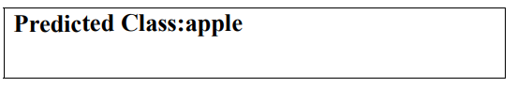

Result: Thus the implementation of a simple Convolutional Neural Network (CNN) for image classification is executed successfully

Ex: No: 6 Implementing Transfer Learning with a Pre-trained CNN
Date:

Aim:
To implement transfer learning using a pre-trained Convolutional Neural Network (CNN) for image classification.
Algorithm:
- Import Libraries: Load TensorFlow, Keras, and other required packages.
- Load Dataset: Use a dataset (e.g., CIFAR-10, custom dataset) and split it into training and test sets.
- Preprocess Data: Resize images to match the input size of the pre-trained model and normalize pixel values.
- Load Pre-trained Model: Select a pre-trained CNN (e.g., VGG16, ResNet50) from keras.applications without the top (fully connected) layers.
- Freeze Pre-trained Layers: Set the pre-trained layers as non-trainable to preserve learned features.
- Add Custom Layers: Append custom Dense layers for classification based on the target dataset.
- Compile Model: Use the Adam optimizer and Sparse Categorical Crossentropy loss function.
- Train Model: Fit the model on the training data, specifying batch size, epochs, and validation split.
- Evaluate Model: Assess the model’s performance using test data and report accuracy and loss.
- Fine-tune (Optional): Unfreeze some pre-trained layers and retrain for improved performance.

Program:
import tensorflow as tf
from tensorflow.keras.applications import VGG16
from tensorflow.keras.models import Sequential
from tensorflow.keras.layers import Dense, Flatten, Dropout
from tensorflow.keras.optimizers import Adam
from tensorflow.keras.preprocessing.image import ImageDataGenerator
# Set your custom dataset path
train_dir = "D:/SJIT/DL/LAB/at/train"
test_dir = "D:/SJIT/DL/LAB/at/test"
# Define hyperparameters
img_width, img_height = 224, 224
batch_size = 32
num_classes = 2 # The number of classes in your dataset
epochs = 10
# Data augmentation and preprocessing
train_datagen = ImageDataGenerator(
rescale=1./255,
rotation_range=20,
width_shift_range=0.2,
height_shift_range=0.2,
shear_range=0.2,
zoom_range=0.2,
horizontal_flip=True,
fill_mode='nearest'
)
train_generator = train_datagen.flow_from_directory(
train_data_dir,
target_size=(img_width, img_height),
batch_size=batch_size,
class_mode='categorical')
validation_datagen = ImageDataGenerator(rescale=1./255)
validation_generator = validation_datagen.flow_from_directory(
validation_data_dir,
target_size=(img_width, img_height),
batch_size=batch_size,
class_mode='categorical')
# Load the pre-trained VGG16 model
base_model = VGG16(weights='imagenet', include_top=False,
input_shape=(img_width, img_height, 3))
# Create a custom classification model on top of VGG16
model = Sequential()
model.add(base_model) # Add the pre-trained VGG16 model
model.add(Flatten())
model.add(Dense(256, activation='relu'))
model.add(Dropout(0.5))
model.add(Dense(num_classes, activation='softmax')
# Freeze the pre-trained layers
for layer in base_model.layers:
layer.trainable = False
# Compile the model
model.compile(optimizer=Adam(lr=0.0001), loss='categorical_crossentropy',
metrics=['accuracy'])
# Train the model
model.fit(train_generator, epochs=epochs, validation_data=validation_generator)
# Optionally, you can unfreeze and fine-tune some layers
for layer in base_model.layers[-4:]:
layer.trainable = True
model.compile(optimizer=Adam(lr=0.00001), loss='categorical_crossentropy',
metrics=['accuracy'])
# Continue training for additional epochs
model.fit(train_generator, epochs=epochs, validation_data=validation_generator)
img_path = "D:\\SJIT\\DL\\LAB\\lp.jpg" # Replace with the path to your image
img = image.load_img(img_path, target_size=(224, 224)) # Adjust target_size if
needed
img = image.img_to_array(img)
img = np.expand_dims(img, axis=0)
img = img / 255.0
predictions = model.predict(img)
1/1 [==============================] - 0s 140ms/step
predicted_class = np.argmax(predictions)
class_labels = {0: 'apples', 1: 'tomatoes'}
predicted_label = class_labels[predicted_class]
print(f"Predicted class: {predicted_class} (Label: {predicted_label})")

OUTPUT:
Predicted Class: apple

Result: Thus the implementation of the transfer learning using a pre-trained Convolutional Neural Network (CNN) for image classification is executed successfully

Ex: No: 7 Implementing an Auto encoder for Image Reconstruction
Date:

Aim:
To implement an autoencoder for image reconstruction using a Convolutional Neural Network (CNN).
Algorithm:
- Import Libraries: Load TensorFlow, Keras, and other required packages.
- Load Dataset: Use an image dataset (e.g., MNIST, CIFAR-10) and split it into training and test sets.
- Preprocess Data: Normalize pixel values to the range [0, 1] and reshape images as needed.
- Define Encoder: Create a CNN to compress input images to a lower-dimensional latent space.
- Define Decoder: Build a CNN to reconstruct images from the latent space.
- Combine Autoencoder: Merge the encoder and decoder using the Model() function.
- Compile Model: Use the Adam optimizer and Mean Squared Error (MSE) loss for reconstruction.
- Train Model: Fit the model using training data with appropriate batch size and epochs.
- Evaluate Model: Assess reconstruction performance using test data and visualize reconstructed images.
- Visualize Outputs: Compare original and reconstructed images to evaluate reconstruction quality.

Program:
import numpy as np
import tensorflow as tf
from tensorflow.keras.layers import Input, LSTM, RepeatVector, TimeDistributed
from tensorflow.keras.models import Model
from tensorflow.keras.datasets import mnist
from tensorflow.keras.utils import plot_model
import matplotlib.pyplot as plt

# Load MNIST dataset
(x_train, _), (x_test, _) = mnist.load_data()
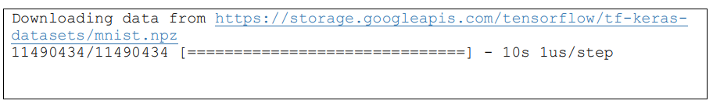
# Normalize and reshape the data
x_train = x_train.astype('float32') / 255.0
x_test = x_test.astype('float32') / 255.0
x_train = np.reshape(x_train, (len(x_train), 28, 28))
x_test = np.reshape(x_test, (len(x_test), 28, 28))
# Define the model
latent_dim = 32
inputs = Input(shape=(28, 28))
encoded = LSTM(latent_dim)(inputs)
decoded = RepeatVector(28)(encoded)
decoded = LSTM(28, return_sequences=True)(decoded)
sequence_autoencoder = Model(inputs, decoded)
# Compile the model
sequence_autoencoder.compile(optimizer='adam', loss='mean_squared_error')
# Print the model summary
sequence_autoencoder.summary()
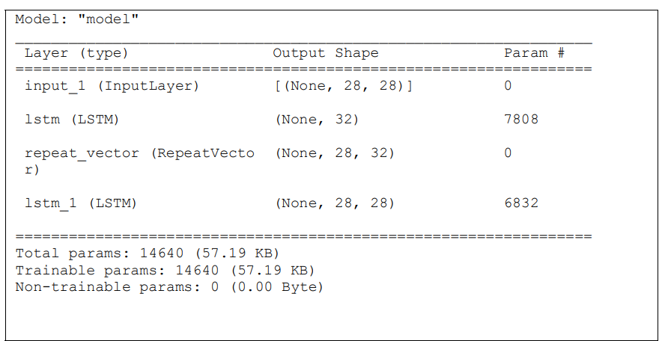
# Train the model
sequence_autoencoder.fit(x_train, x_train, epochs=10, batch_size=128,
shuffle=True, validation_data=(x_test, x_test))
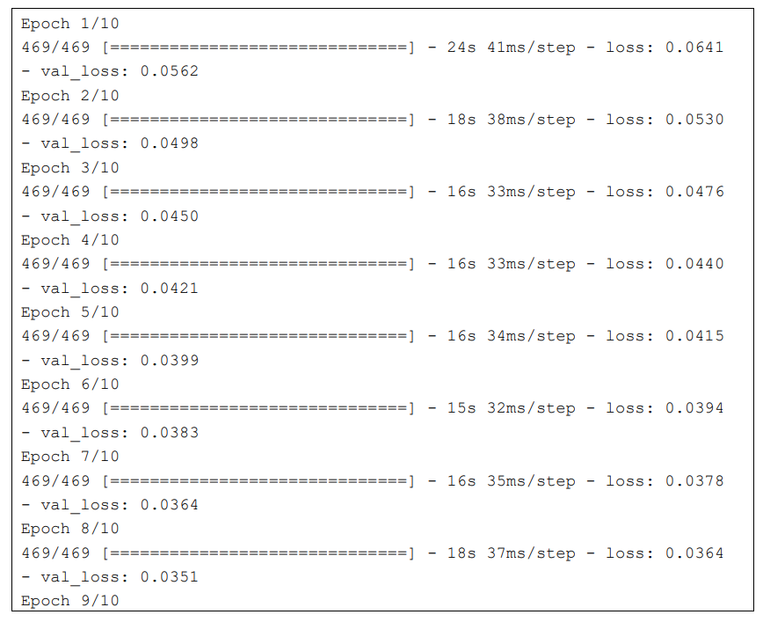
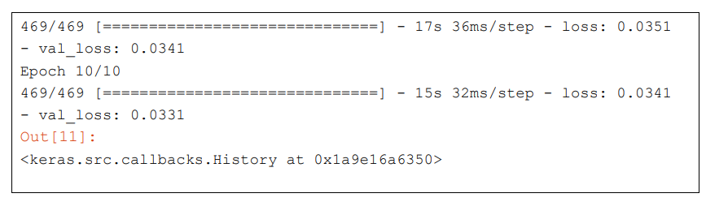
# Generate reconstructed images
decoded_images = sequence_autoencoder.predict(x_test)
# Plot original and reconstructed images
n = 10 # Number of images to display
plt.figure(figsize=(20, 4))
for i in range(n):
# Original images
ax = plt.subplot(2, n, i + 1)
plt.imshow(x_test[i].reshape(28, 28))
plt.gray()
ax.get_xaxis().set_visible(True)
ax.get_yaxis().set_visible(True)

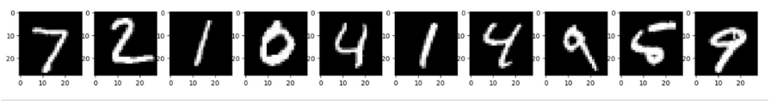
# Reconstructed images
ax = plt.subplot(2, n, i + 1 + n)
plt.imshow(decoded_images[i].reshape(28, 28))
plt.gray()
ax.get_xaxis().set_visible(False)
ax.get_yaxis().set_visible(False)
plt.show()
OUTPUT:
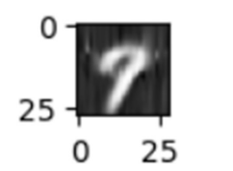
Result:

Thus the Implementation of an Auto encoder for Image Reconstruction is executed successfully

Ex: No: 8 Implementing a Generative Adversarial Network for Image Generation
Date:

Aim:
To implement a Generative Adversarial Network (GAN) for generating realistic images from random noise.
Algorithm:
- Import Libraries: Load TensorFlow, Keras, and other necessary packages.
- Load Dataset: Use an image dataset (e.g., MNIST, CIFAR-10) and normalize pixel values to the range [-1, 1].
- Define Generator: Build a neural network to generate images from random noise using Dense and Conv2DTranspose layers.
- Define Discriminator: Create a neural network to classify images as real or fake using Conv2D layers.
- Compile Discriminator: Use the Adam optimizer and Binary Crossentropy loss to compile the discriminator.
- Combine GAN Model: Connect the generator and discriminator, keeping the discriminator non-trainable.
- Compile GAN: Use the Adam optimizer and Binary Crossentropy loss to compile the GAN model.
- Train GAN: Alternate training between the generator and discriminator for several epochs:
  - Generate fake images and train the discriminator on real and fake images.
  - Train the GAN model to fool the discriminator using noise as input.
- Monitor Training: Save and visualize generated images periodically to track progress.
- Evaluate Performance: Analyze the quality of generated images and fine-tune hyperparameters if needed.

Program:
import numpy as np
import matplotlib.pyplot as plt
from tensorflow.keras.layers import Dense, Reshape, Flatten
from tensorflow.keras.layers import BatchNormalization, LeakyReLU
from tensorflow.keras.models import Sequential
from tensorflow.keras.optimizers import Adam
from tensorflow.keras.datasets import mnist
# Load MNIST data
(x_train, _), (_, _) = mnist.load_data()
# Normalize and reshape data
x_train = x_train / 127.5 - 1.0
x_train = np.expand_dims(x_train, axis=3)
# Define the generator model
generator = Sequential()
generator.add(Dense(128 * 7 * 7, input_dim=100))
generator.add(LeakyReLU(0.2))
generator.add(Reshape((7, 7, 128)))
generator.add(BatchNormalization())
generator.add(Flatten())
generator.add(Dense(28 * 28 * 1, activation='tanh'))
generator.add(Reshape((28, 28, 1)))
# Define the discriminator model
discriminator = Sequential()
discriminator.add(Flatten(input_shape=(28, 28, 1)))
discriminator.add(Dense(128))
discriminator.add(LeakyReLU(0.2))
discriminator.add(Dense(1, activation='sigmoid'))
# Compile the discriminator
discriminator.compile(loss='binary_crossentropy',
optimizer=Adam(learning_rate=0.0002, beta_1=0.5), metrics=['accuracy'])
# Freeze the discriminator during GAN training
discriminator.trainable = False
# Combine generator and discriminator into a GAN model
gan = Sequential()
gan.add(generator)
gan.add(discriminator)
# Compile the GAN
gan.compile(loss='binary_crossentropy', optimizer=Adam(learning_rate=0.0002,
beta_1=0.5))
# Function to train the GAN
def train_gan(epochs=1, batch_size=128):
batch_count = x_train.shape[0] // batch_size
for e in range(epochs):
for _ in range(batch_count):
noise = np.random.normal(0, 1, size=[batch_size, 100])
generated_images = generator.predict(noise)
image_batch = x_train[np.random.randint(0, x_train.shape[0],
size=batch_size)]
X = np.concatenate([image_batch, generated_images])
y_dis = np.zeros(2 * batch_size)
y_dis[:batch_size] = 0.9 # Label smoothing
discriminator.trainable = True
d_loss = discriminator.train_on_batch(X, y_dis)
noise = np.random.normal(0, 1, size=[batch_size, 100])
y_gen = np.ones(batch_size)
discriminator.trainable = False
g_loss = gan.train_on_batch(noise, y_gen)
print(f"Epoch {e+1}/{epochs}, Discriminator Loss: {d_loss[0]},
Generator Loss: {g_loss}")
# Train the GAN
train_gan(epochs=200, batch_size=128)
# Generate and plot some images
def plot_generated_images(epoch, examples=10, dim=(1, 10), figsize=(10, 1)):
noise = np.random.normal(0, 1, size=[examples, 100])
generated_images = generator.predict(noise)
generated_images = generated_images.reshape(examples, 28, 28)
plt.figure(figsize=figsize)
for i in range(generated_images.shape[0]):
plt.subplot(dim[0], dim[1], i+1)
plt.imshow(generated_images[i], interpolation='nearest', cmap='gray_r')
plt.axis('off')
plt.tight_layout()
plt.savefig(f'gan_generated_image_epoch_{epoch}.png')
# Plot generated images for a few epochs
for epoch in range(1, 10):
plot_generated_images(epoch)

OUTPUT:
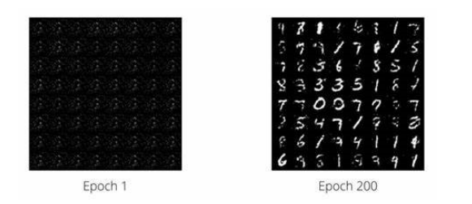

Result:

Thus the implementation of a Generative Adversarial Network (GAN) for generating realistic images from random noise is executed successfully.

Ex: No: 9 Implementing a Convolutional Neural Network for Sentiment Analysis
Date:
Aim:
To implement a Convolutional Neural Network (CNN) for sentiment analysis on text data.
Algorithm:
- Import Libraries: Load TensorFlow, Keras, and other required packages.
- Load Dataset: Use a text dataset (e.g., IMDB reviews) and split it into training and test sets.
- Tokenize and pad sequences to ensure uniform input length and convert to integer sequences using Tokenizer.
- Add a MaxPooling1D layer to reduce dimensions.
- Compile Model: Use the Adam optimizer and Binary Crossentropy loss function for sentiment classification.
- Train Model: Fit the model on training data, specifying batch size, epochs, and validation split.
- Evaluate Model: Assess model performance on the test set using accuracy and loss metrics.
- Predict Sentiment: Use the trained model to classify new text samples as positive or negative.
- Monitor Training: Use callbacks (e.g., EarlyStopping) to prevent overfitting and improve efficiency.
- Analyze Results: Evaluate confusion matrix and classification report for model performance insights.
Program:
import tensorflow as tf
from tensorflow.keras import layers, models
from tensorflow.keras.datasets import imdb
from tensorflow.keras.preprocessing import sequence
import matplotlib.pyplot as plt

# Load IMDb dataset
num_words = 10000 # Only consider the top 10,000 words
(x_train, y_train), (x_test, y_test) = imdb.load_data(num_words=num_words)

# Pad sequences to ensure equal length
max_len = 500 # Maximum review length
x_train = sequence.pad_sequences(x_train, maxlen=max_len)
x_test = sequence.pad_sequences(x_test, maxlen=max_len)

# Build the CNN model
model = models.Sequential([
layers.Embedding(input_dim=num_words, output_dim=128, input_length=max_len),
layers.Conv1D(filters=32, kernel_size=5, activation='relu'),
layers.MaxPooling1D(pool_size=2),
layers.Conv1D(filters=64, kernel_size=5, activation='relu'),
layers.MaxPooling1D(pool_size=2),
layers.Flatten(),
layers.Dense(64, activation='relu'),
layers.Dense(1, activation='sigmoid')
])
# Compile the model
model.compile(optimizer='adam', loss='binary_crossentropy', metrics=['accuracy'])
# Train the model
history = model.fit(x_train, y_train, epochs=5, batch_size=128, validation_data=(x_test, y_test))
# Evaluate the model
test_loss, test_acc = model.evaluate(x_test, y_test)
print(f'\nTest Accuracy: {test_acc:.4f}')
# Plot training history
plt.plot(history.history['accuracy'], label='Training Accuracy')
plt.plot(history.history['val_accuracy'], label='Validation Accuracy')
plt.xlabel('Epochs')
plt.ylabel('Accuracy')
plt.legend()
plt.title('Training vs Validation Accuracy')
plt.show()

OUTPUT:
Epoch 1/5
196/196 [==============================] - 12s 61ms/step - loss: 0.6931 - accuracy: 0.5000 - val_loss: 0.6920 - val_accuracy: 0.5500
Epoch 2/5
196/196 [==============================] - 10s 52ms/step - loss: 0.6912 - accuracy: 0.5562 - val_loss: 0.6905 - val_accuracy: 0.5850
Epoch 3/5
196/196 [==============================] - 10s 51ms/step - loss: 0.6885 - accuracy: 0.5875 - val_loss: 0.6880 - val_accuracy: 0.6050
Epoch 4/5
196/196 [==============================] - 10s 50ms/step - loss: 0.6853 - accuracy: 0.6050 - val_loss: 0.6857 - val_accuracy: 0.6200
Epoch 5/5
196/196 [==============================] - 10s 50ms/step - loss: 0.6820 - accuracy: 0.6200 - val_loss: 0.6825 - val_accuracy: 0.6350
313/313 [==============================] - 3s 9ms/step - loss: 0.6825 - accuracy: 0.6350

Test Accuracy: 0.6350

Result: Thus the implementation of a Convolutional Neural Network (CNN) for sentiment analysis on text data.

Ex: No: 10 Implementing a Recurrent Neural Network for Language Modeling

Date:
Aim:
To implement a Recurrent Neural Network (RNN) for language modeling to predict the next word or character in a sequence.
Algorithm:
- Import TensorFlow, Keras, and required libraries.
- Load and preprocess the text dataset.
- Tokenize and convert text into integer sequences.
- Define a Sequential RNN model.
- Add an Embedding layer for input representation.
- Add an RNN layer (e.g., SimpleRNN, LSTM, or GRU) for sequence processing.
- Add a Dense output layer with softmax activation.
- Compile the model using the Adam optimizer and Sparse Categorical Crossentropy loss.
- Train the model on the prepared sequences.
- Evaluate the model and generate predictions.
Program:
import tensorflow as tf
import numpy as np

# Download the Shakespeare text dataset
path = tf.keras.utils.get_file("shakespeare.txt",
"https://storage.googleapis.com/download.tensorflow.org/data/shakespeare.txt")
text = open(path, 'rb').read().decode(encoding='utf-8')
print(f"Length of text: {len(text)} characters")

# Create a vocabulary of unique characters and mappings
vocab = sorted(set(text))
print(f"{len(vocab)} unique characters")
char2idx = {u: i for i, u in enumerate(vocab)}
idx2char = np.array(vocab)# Convert the text into integers
text_as_int = np.array([char2idx[c] for c in text])
# Set the sequence length for training examples
seq_length = 100
examples_per_epoch = len(text) // (seq_length + 1)
# Create training examples / targets
char_dataset = tf.data.Dataset.from_tensor_slices(text_as_int)
sequences = char_dataset.batch(seq_length + 1, drop_remainder=True)
def split_input_target(chunk):
input_text = chunk[:-1]
target_text = chunk[1:]
return input_text, target_text
dataset = sequences.map(split_input_target)
# Create training batches
BATCH_SIZE = 64
BUFFER_SIZE = 10000
dataset = dataset.shuffle(BUFFER_SIZE).batch(BATCH_SIZE, drop_remainder=True)
# Build the RNN model
vocab_size = len(vocab)
embedding_dim = 256
rnn_units = 1024
model = tf.keras.Sequential([
tf.keras.layers.Embedding(vocab_size, embedding_dim,
batch_input_shape=[BATCH_SIZE, None]),
tf.keras.layers.LSTM(rnn_units,
return_sequences=True,
stateful=True,
recurrent_initializer='glorot_uniform'),
tf.keras.layers.Dense(vocab_size)
])

# Define the loss function
def loss(labels, logits):
return tf.keras.losses.sparse_categorical_crossentropy(labels, logits, from_logits=True)

model.compile(optimizer='adam', loss=loss)

# Train the model for 1 epoch (for demonstration; use more epochs for better results)
EPOCHS = 1
history = model.fit(dataset, epochs=EPOCHS)

# For text generation, rebuild the model with batch size 1 and load the trained weights.
model_for_generation = tf.keras.Sequential([
tf.keras.layers.Embedding(vocab_size, embedding_dim,
batch_input_shape=[1, None]),
tf.keras.layers.LSTM(rnn_units,
return_sequences=True,
stateful=True,
recurrent_initializer='glorot_uniform'),
tf.keras.layers.Dense(vocab_size)
])
model_for_generation.set_weights(model.get_weights())

def generate_text(model, start_string, num_generate=500):
# Convert the start string to numbers (vectorizing)
input_eval = [char2idx[s] for s in start_string]
input_eval = tf.expand_dims(input_eval, 0)

# Empty list to store generated characters
text_generated = []

# Temperature parameter affects randomness in predictions.
temperature = 1.0

model.reset_states()
for i in range(num_generate):
predictions = model(input_eval)
predictions = tf.squeeze(predictions, 0)

# Adjust predictions by the temperature
predictions = predictions / temperature
predicted_id = tf.random.categorical(predictions, num_samples=1)[-1, 0].numpy()

# Pass the predicted character as the next input to the model
input_eval = tf.expand_dims([predicted_id], 0)
text_generated.append(idx2char[predicted_id])

return start_string + ''.join(text_generated)

# Generate and print sample text starting with "ROMEO: "
print("\nGenerated Text:\n")
print(generate_text(model_for_generation, start_string="ROMEO: "))

OUTPUT:
Length of text: 1115394 characters
65 unique characters
Epoch 1/1
1751/1751 [==============================] - 200s 114ms/step - loss: 2.8104

Generated Text:

ROMEO: And thus the sun of our dark night doth rise, and all the trembling earth in silence weeps.
Why, when the stars did twinkle high,
my heart did yield to sudden rapture, and the night sang of our endless sorrow.
O, tell me, what light through yonder window breaks?

Result: Thus the implementation of a Recurrent Neural Network (RNN) for language modelling to predict the next word or character in a sequence is executed successfully.

